Chapter 3, Solution 9

Let V₁ be the unknown node voltage to the right of the 250-Ω resistor. Let the ground reference be placed at the bottom of the 50-Ω resistor. This leads to the following nodal equation:

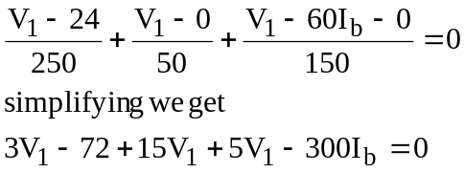

But 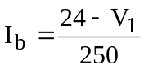. Substituting this into the nodal equation leads to

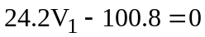 or V₁ = 4.165 V.

Thus, I_{b} = (24 – 4.165)/250 = 79.34 mA.

